Code:

from pydub import AudioSegment

import numpy as np

import matplotlib.pyplot as plt

from scipy.signal import convolve

# Load MP3 file

audio = AudioSegment.from_mp3("/content/Yeh Jeevan Hai (Piya Ka Ghar) - (Raag.Fm).mp3")

# Convert to mono and extract raw samples

audio = audio.set_channels(1)

samples = np.array(audio.get_array_of_samples()).astype(np.float32)

# Define convolution kernel

kernel = np.array([1, 0, 1, 0, ], dtype=np.float32)

# Perform convolution

convoluted = convolve(samples, kernel, mode='same')

# Normalize to int16 range for saving

convoluted = convoluted / np.max(np.abs(convoluted))

convoluted_int16 = (convoluted * 32767).astype(np.int16)

# Save as WAV using PyDub

convoluted_audio = AudioSegment(

convoluted_int16.tobytes(),

frame_rate=audio.frame_rate,

sample_width=2, # 16-bit samples = 2 bytes

channels=1

)

# Export to file

convoluted_audio.export("output_convoluted.wav", format="wav")

print("Convoluted audio saved as 'output_convoluted.wav'.")

# Plot original and convoluted signals (optional)

samples_norm = samples / np.max(np.abs(samples))

convoluted_norm = convoluted

plt.figure(figsize=(12, 6))

plt.subplot(2, 1, 1)

plt.plot(samples_norm, color='blue')

plt.title("Original Audio Signal")

plt.subplot(2, 1, 2)

plt.plot(convoluted_norm, color='red')

plt.title("Convoluted Audio Signal with Kernel [1, 0, 1, 0, 1]")

plt.tight_layout()

plt.show()

Output:

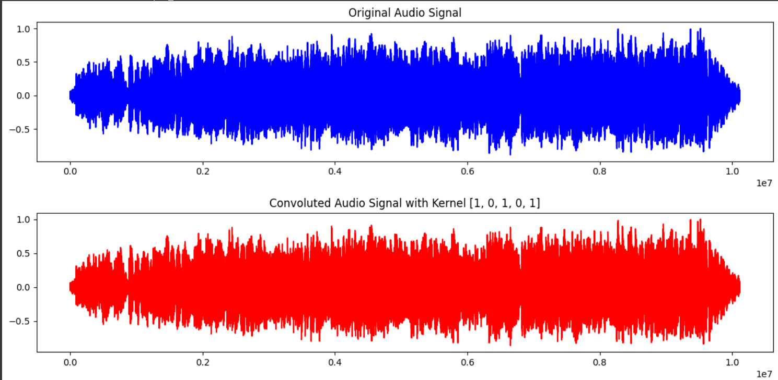

Conclusion:

In this experiment, we altered the waveform of an audio signal by performing convolution on it using a predefined kernel. We showed how convolution can be used to change audio properties by first converting the audio to mono, then extracting its samples, and finally applying the convolution operation. The outcome, which displayed observable variations in waveform shape, was saved as a new WAV file and displayed alongside the original signal. This demonstrates how convolution can be used practically in digital audio processing for sound effects like echo and filtering.